italian pasta salad
ingredients
1-1½ cups cooked rotini noodles
or other pasta
¼ medium cucumber
¼ bell pepper
½ medium roma tomato
or ½ cup cherry tomatoes
½ avocado
1-2 tbsp olive oil
Salt and pepper to taste
Italian seasoning or oregano to taste

And

2 cups self-rising flour
Chopped walnuts, pecans, chocolate chips, etc
1 servings | 10 minutes | 10 minutes total

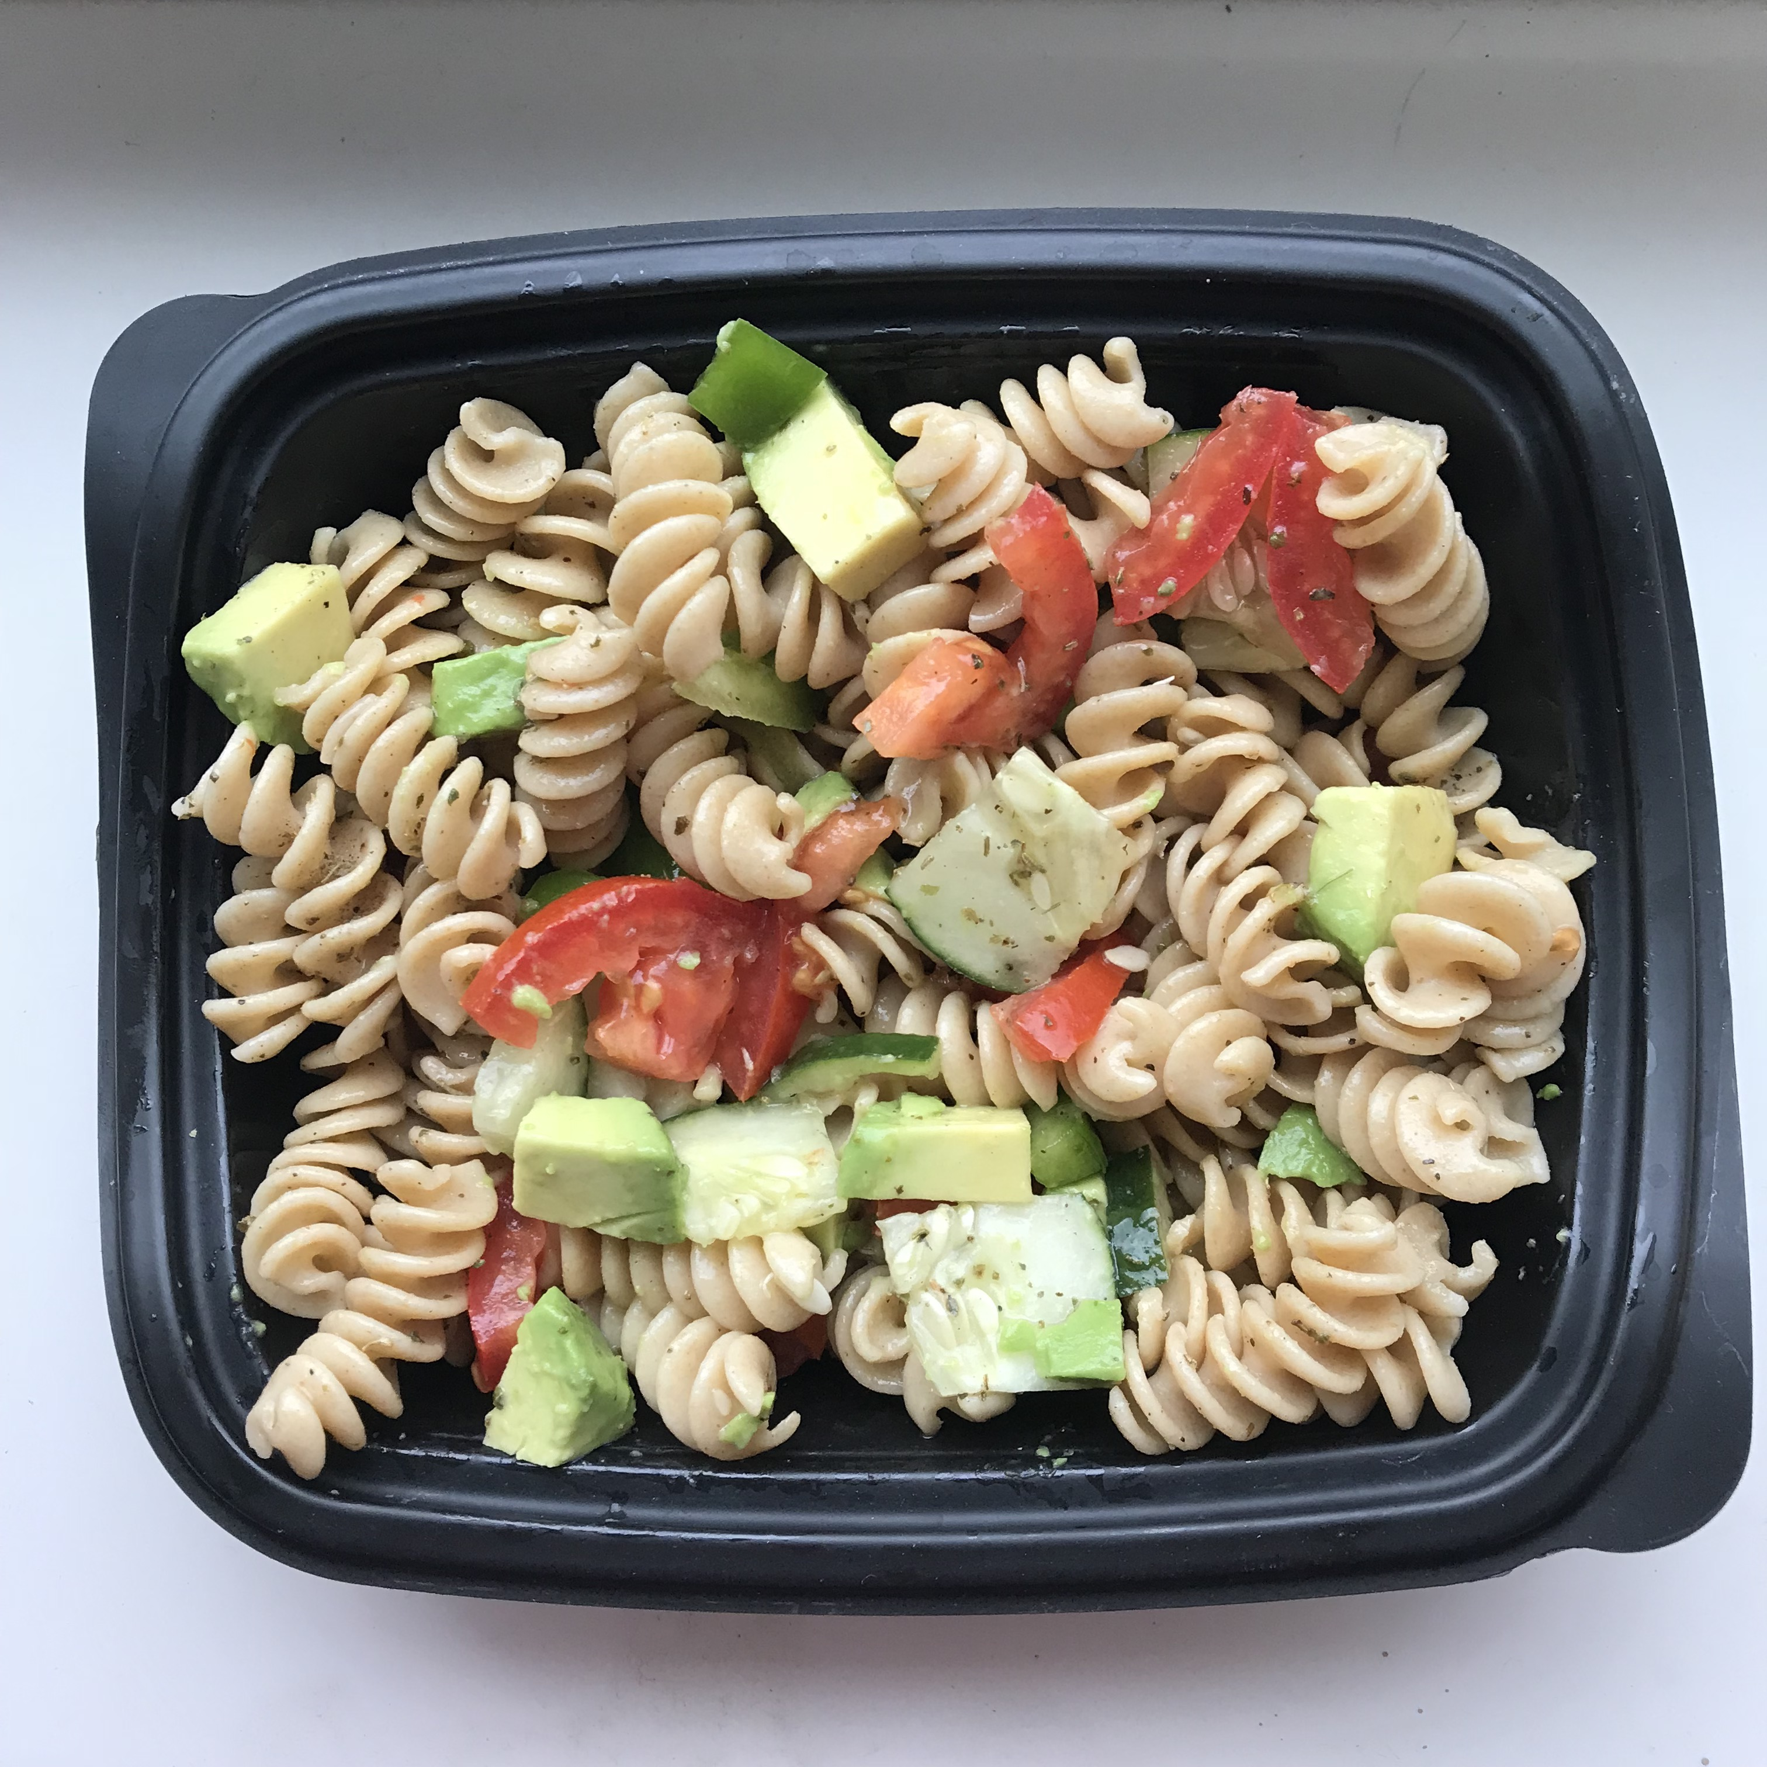
This recipe is great for the end of the week, when you’re running low on groceries. You can add almost anything to this pasta salad and it’s delicious. I made this recipe for one serving, but make as much as you’d like. Seriously, you can’t mess up with pasta salad.

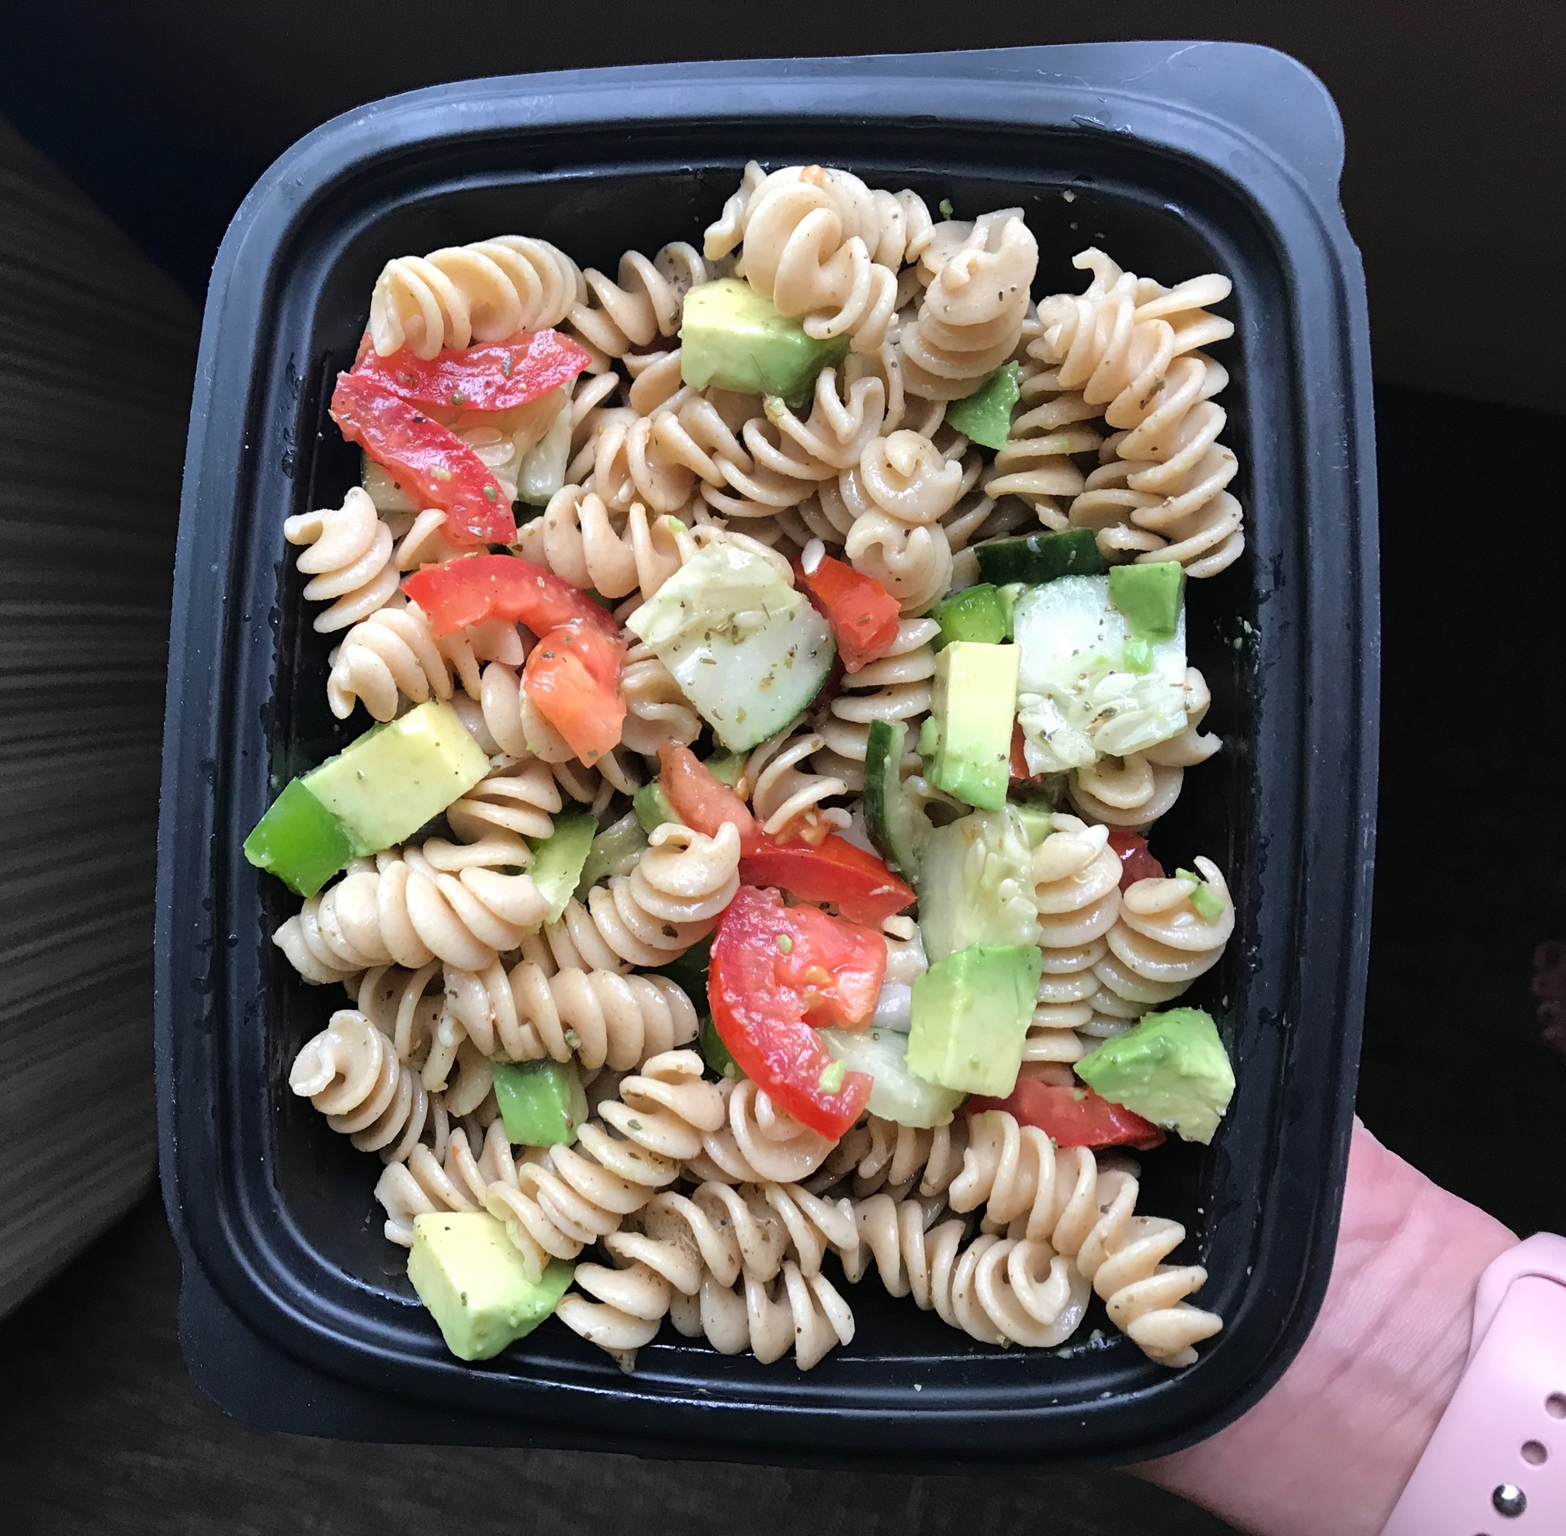
I used veggies left over from my salad this week—cucumber, tomato, avocado, and bell pepper. I chopped all the veggies into bite size pieces and made my own Italian dressing. Again, you can add any seasonings for your desired taste. I chose olive oil, but you could use any oil, mayo, etc.

Directions
If your pasta isn’t already cooked, boil for 8-10 minutes until soft and tender. Drain and rinse with cold water. Chop cucumber, bell pepper, roma tomato, and avocado into bite size pieces. Add to pasta.
For the dressing, I mixed two tablespoons of olive oil with salt, pepper, Italian seasoning, and oregano. I poured this over my pasta and veggies and stirred until everything was well coated with the dressing.

