Beet Quinoa salad
ingredients
1 c. Organic Quinoa
2 c. Water
1 (15.5oz) can Cannellini Beans, drained
1 (15.5oz) can sliced Beets, drained
Salt, to taste
Pepper, to taste
8 c. mixed lettuce
or mixed salad mix
Cherry Tomatoes
2 ripe Avocados
Cucumber, bacon bits, any other salad toppings
Salad dressing, if preferred

4 servings | 20 minutes | 30 minutes total

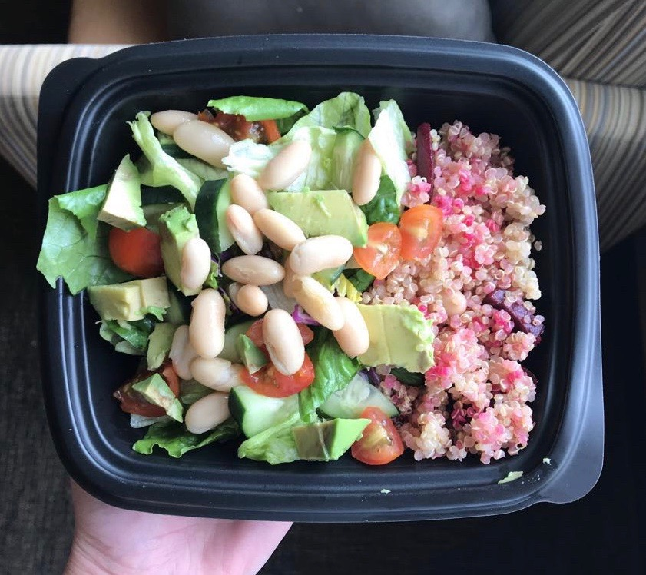
This recipe is perfect for those who want to meal prep, but don’t really know where to start! This quick and easy recipe is simple to make and personalize. Add whatever salad toppings or dressings you like. I love this salad without dressing but it certainly would be great with a homemade vegan ranch dressing!
Feel free to substitute cannellini beans for any other bean. I love chickpeas too and substitute these in for any of my recipes.
To assemble, I sectioned my containers in thirds. My salad took up most of the space, but a third of the bowl was the quinoa mix. This recipe made 4 heaping containers.
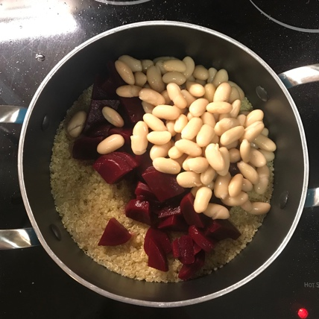
And did I mention this was delicious hot or cold? I actually ate it hot when I first cooked it and ate the leftovers cold.

Directions
First, add quinoa and water to a pot and put on medium heat. Boil for 5 minutes, then simmer on low heat for 20 minutes, or until the quinoa has absorbed all the water. Fluff with a fork.
Slice the beets into small, bite size pieces. If eating this hot, Add the beets and drained cannellini beans to the quinoa and keep on low heat until warm. If chilling, simply add the beets and beans and stir. Refrigerate.
Assemble salads: Add lettuce, chopped tomatoes, sliced avocado, cucumber, beans and any other toppings to a container. Add quinoa mix. Chill and eat within 4-5 days.

