vegan banana bread muffins
ingredients
4 ripe bananas, mashed
½ cup dairy-free butter
¾ cup granulated sugar
2 flax eggs / egg substitute
2 tsp vanilla
¼ non-dairy milk
2 cups self-rising flour
Chopped walnuts, pecans, chocolate chips, etc
6 servings | 10 minutes | 45 minutes total

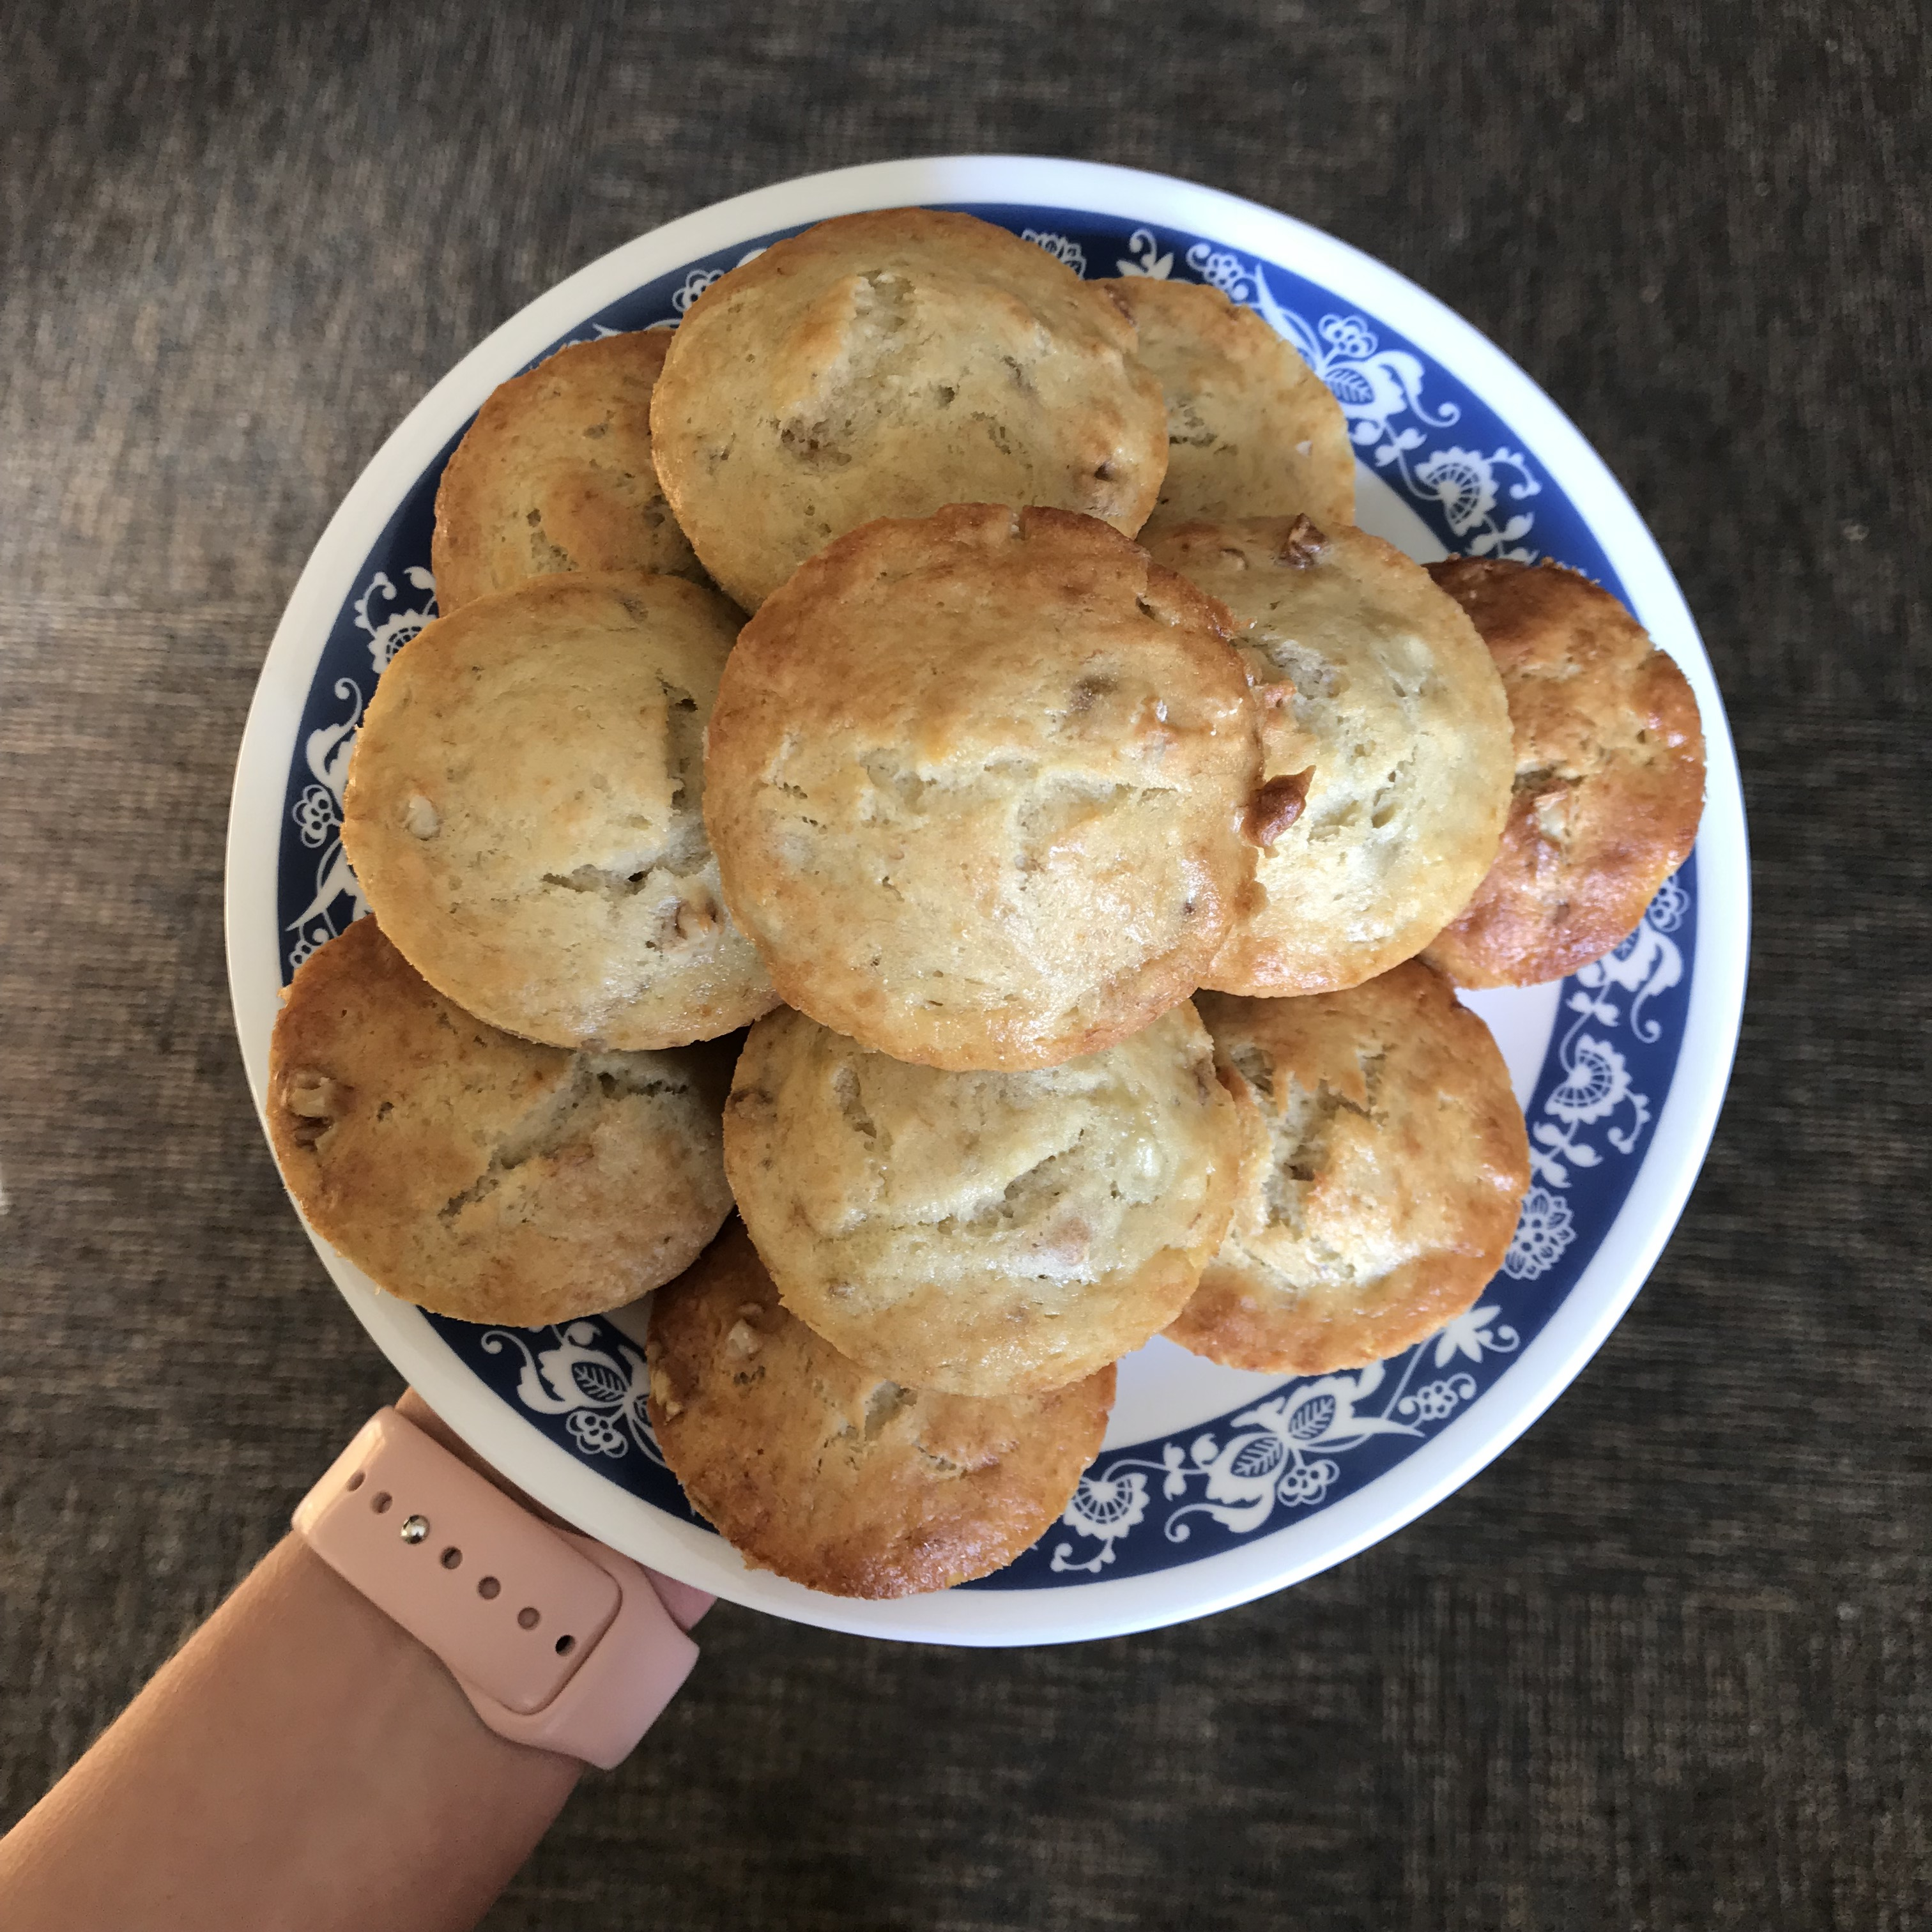
This recipe is sweet and delicious but not too heavy on the stomach. It’s great for on-the-go breakfasts, an afternoon snack, or even dessert.
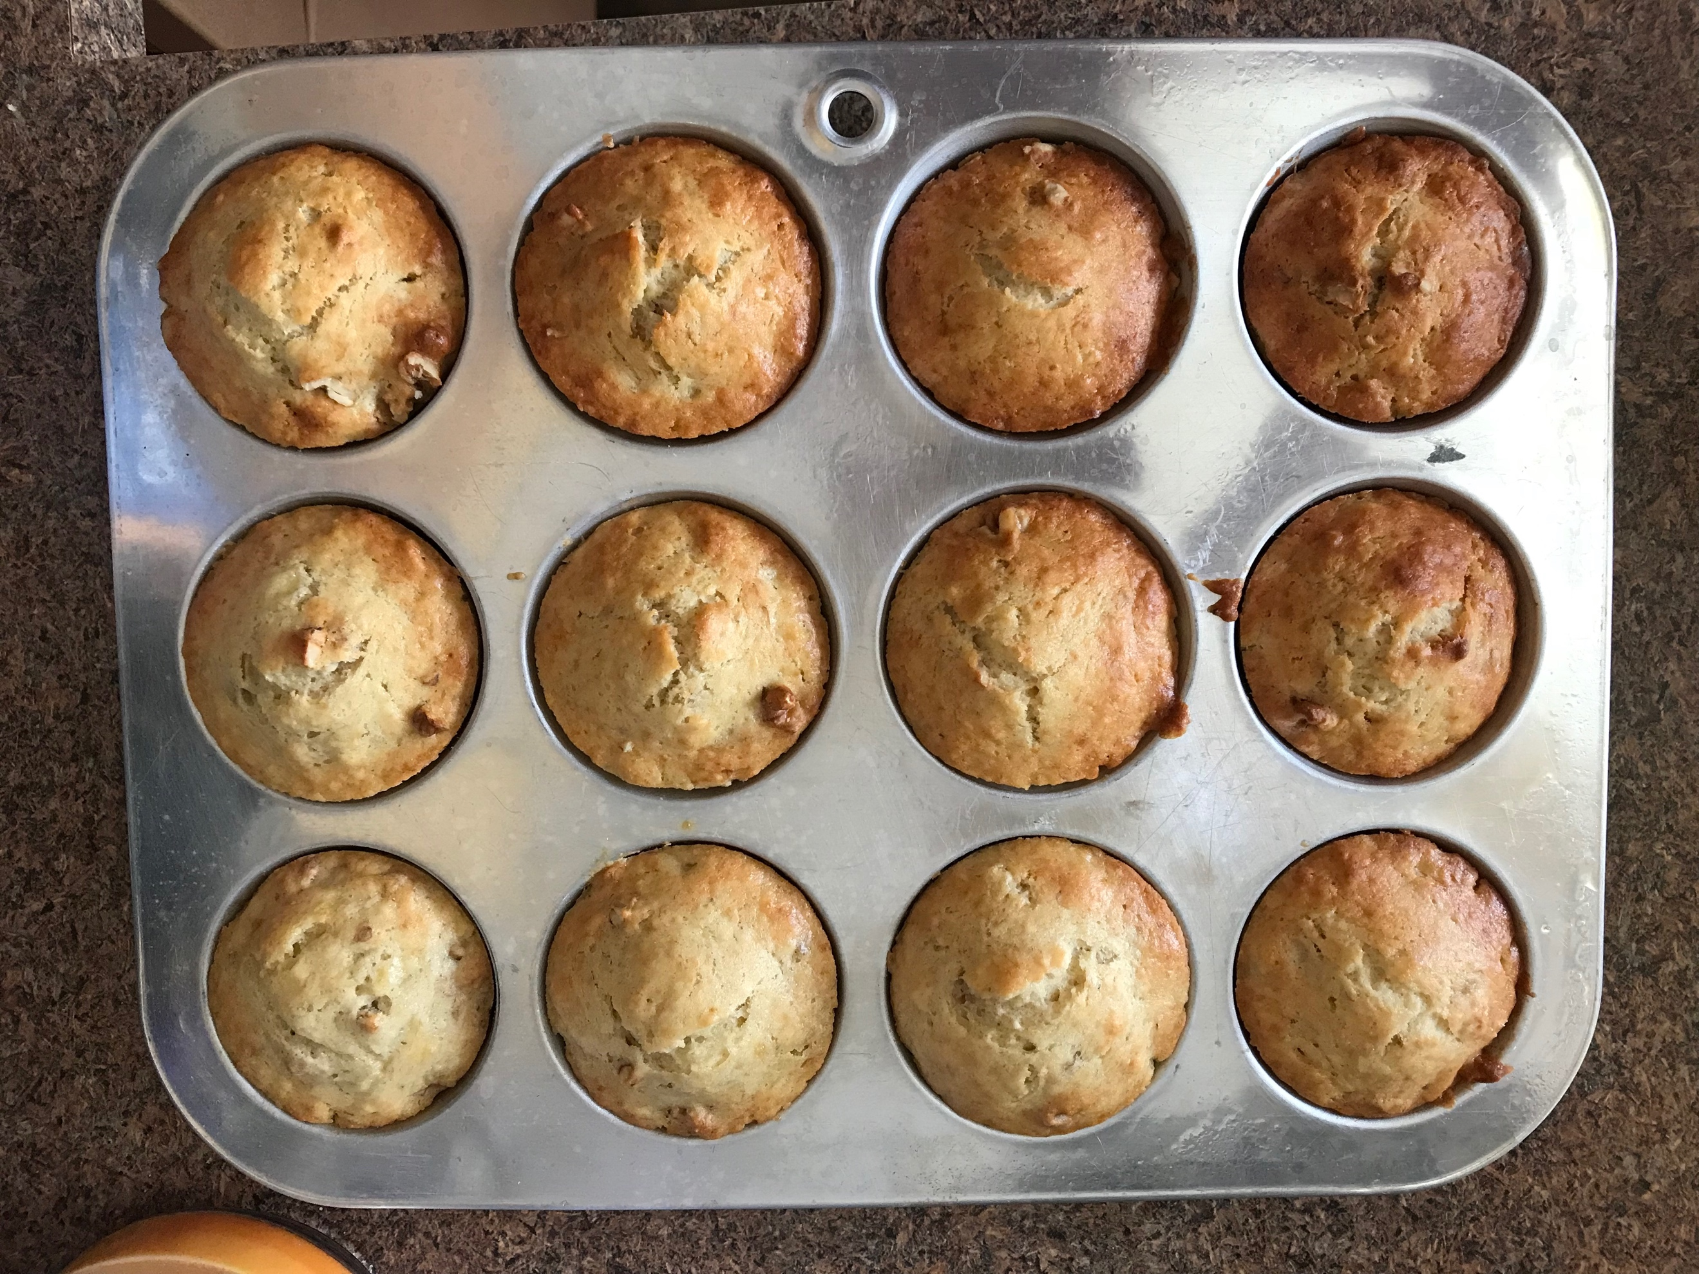
I adapted this banana bread recipe from Baked By An Introvert, who includes buttermilk to make the banana bread extra moist and sweet. I wanted to alter this so it would be suitable for vegans but simple to make. This recipe makes 24 medium-size muffins or one large loaf. Feel free to include whichever toppings and extras to your bread you like, such as chopped pecans, walnuts, or chocolate chips (or all of the above!)

Directions
First, mash your bananas and add the butter, sugar, flax egg, vanilla and milk. Stir well. Add flour and any desired nuts or chocolate and mix.
Coat muffin tin with non-stick spray. If making muffins, fill each tin up ¾ of the way. Bake at 350 degrees for 25-30 minutes, or until the edges are golden brown and a toothpick comes clean from the center. Let cool on a cooling rack and enjoy.

Notes: I always keep ripe bananas in the freezer. When I notice a banana turning brown, I peel it and put it in a Ziplock in the freezer. I love doing this and I always have bananas for baking or making smoothies. Baked By and Introvert describes how to ‘ripen’ a banana in the oven.

